**Azure Logic App**

Overview: This app implements some logic. Here we define a logic as whenever a email arrives to a particular mail-id a blob storage will be created according to the attachment.

**Create a Storage Account**

Open the azure portal select account storage and follow the bellow screen

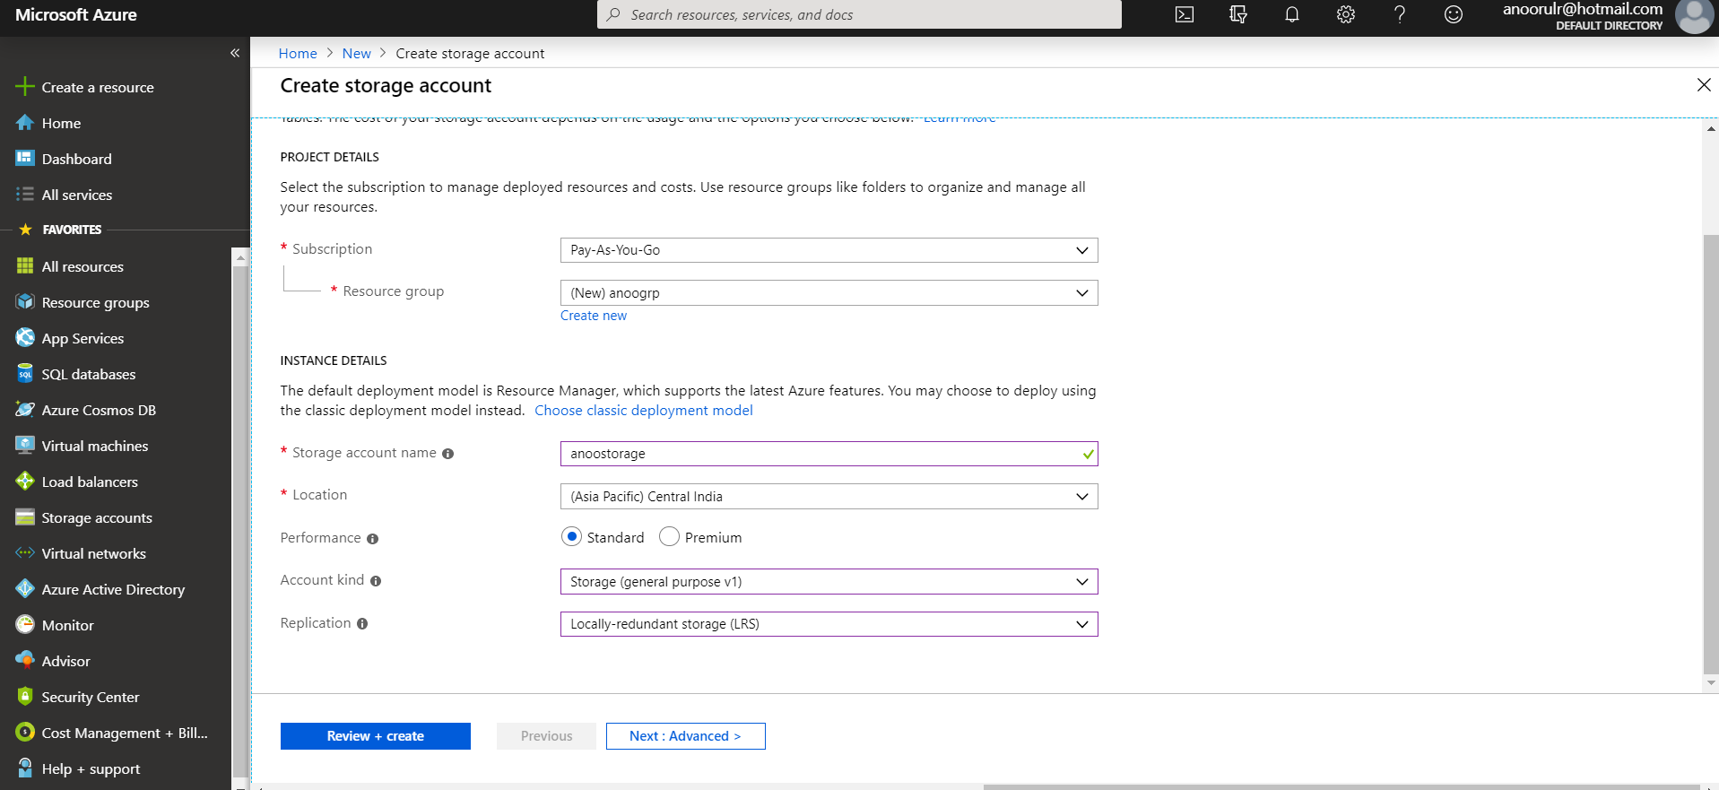

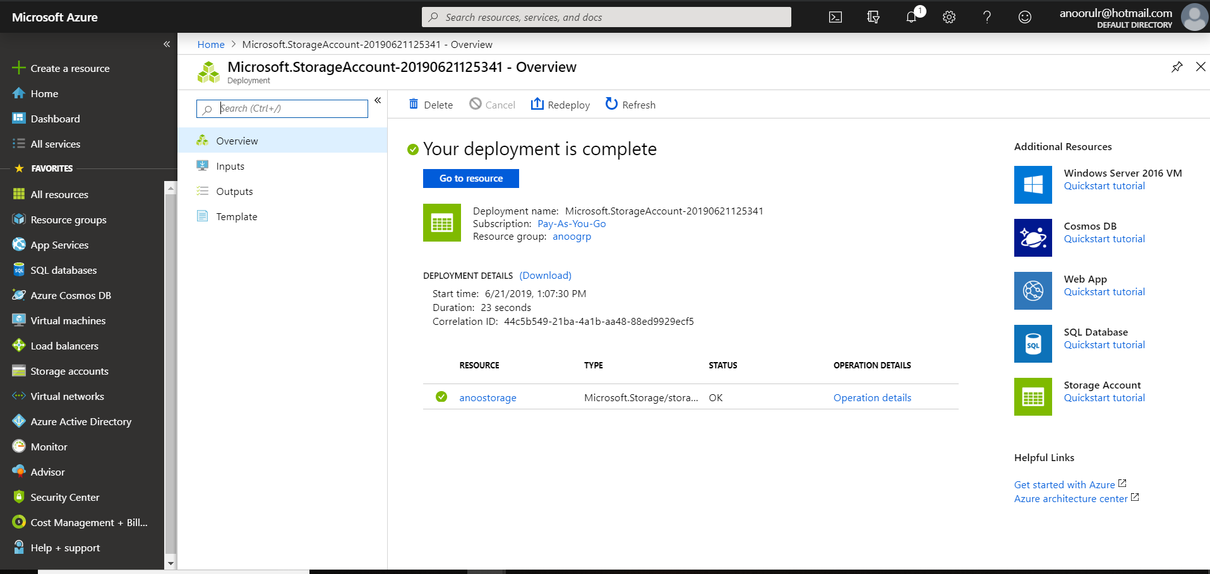

**Create blob Storage**

After successful creation of storage-account you need to create a blob storage. For that you need to click on blob button and follow the below screen to create a blob-container

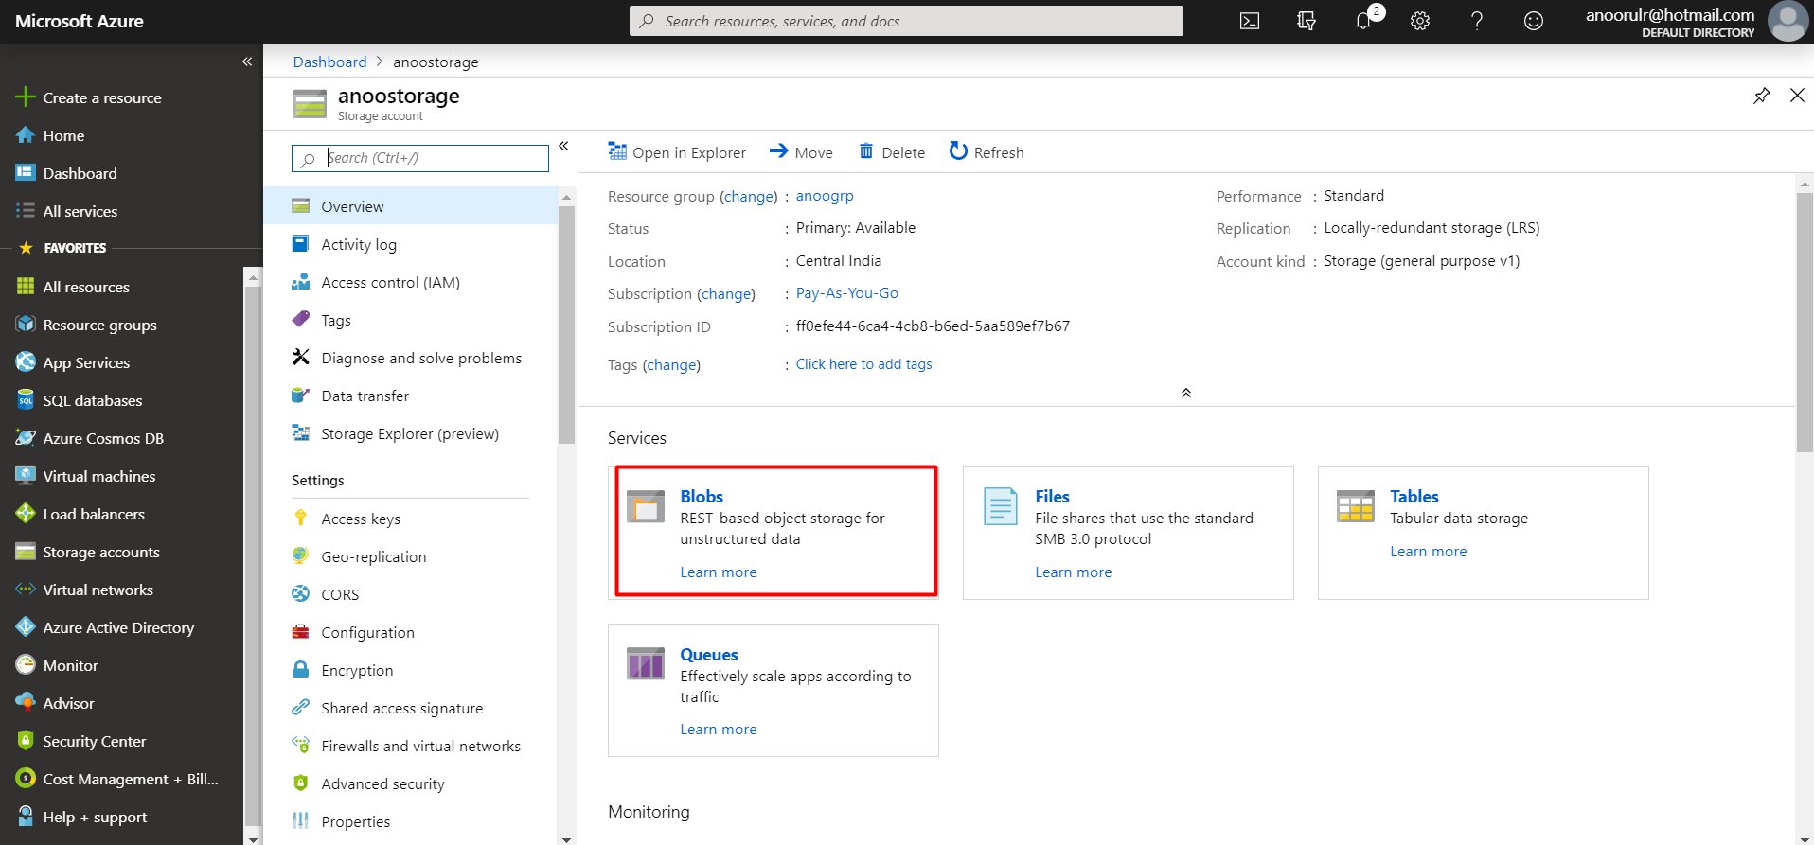

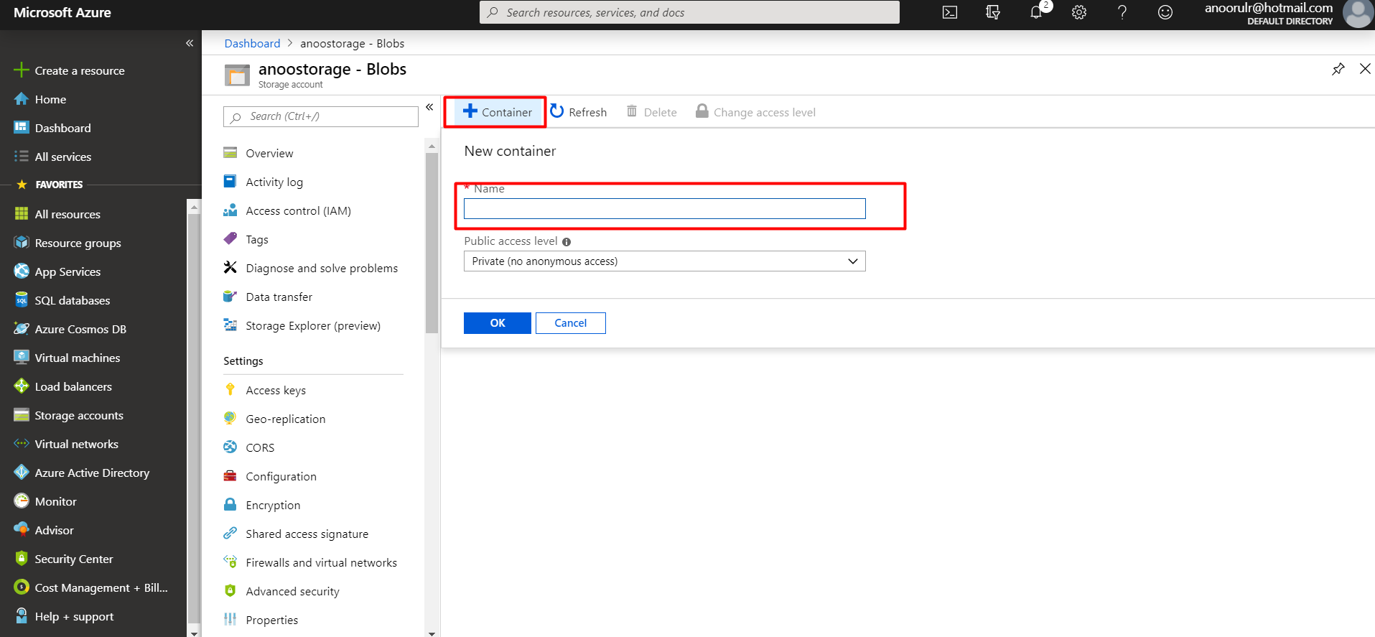

Need to enter

Name: User define identifier.

Access Level: Select the access level as your requirement.

Press **OK** to finish the creation of a container.

**Logic** **App**:

Search ‘Logic App’ in ‘new resource’ window as follow

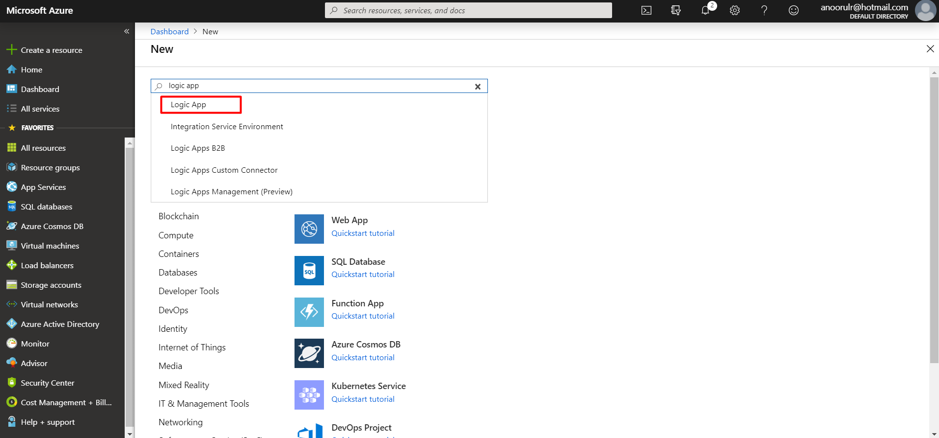

When you choose logic app from dropdown the following window will open

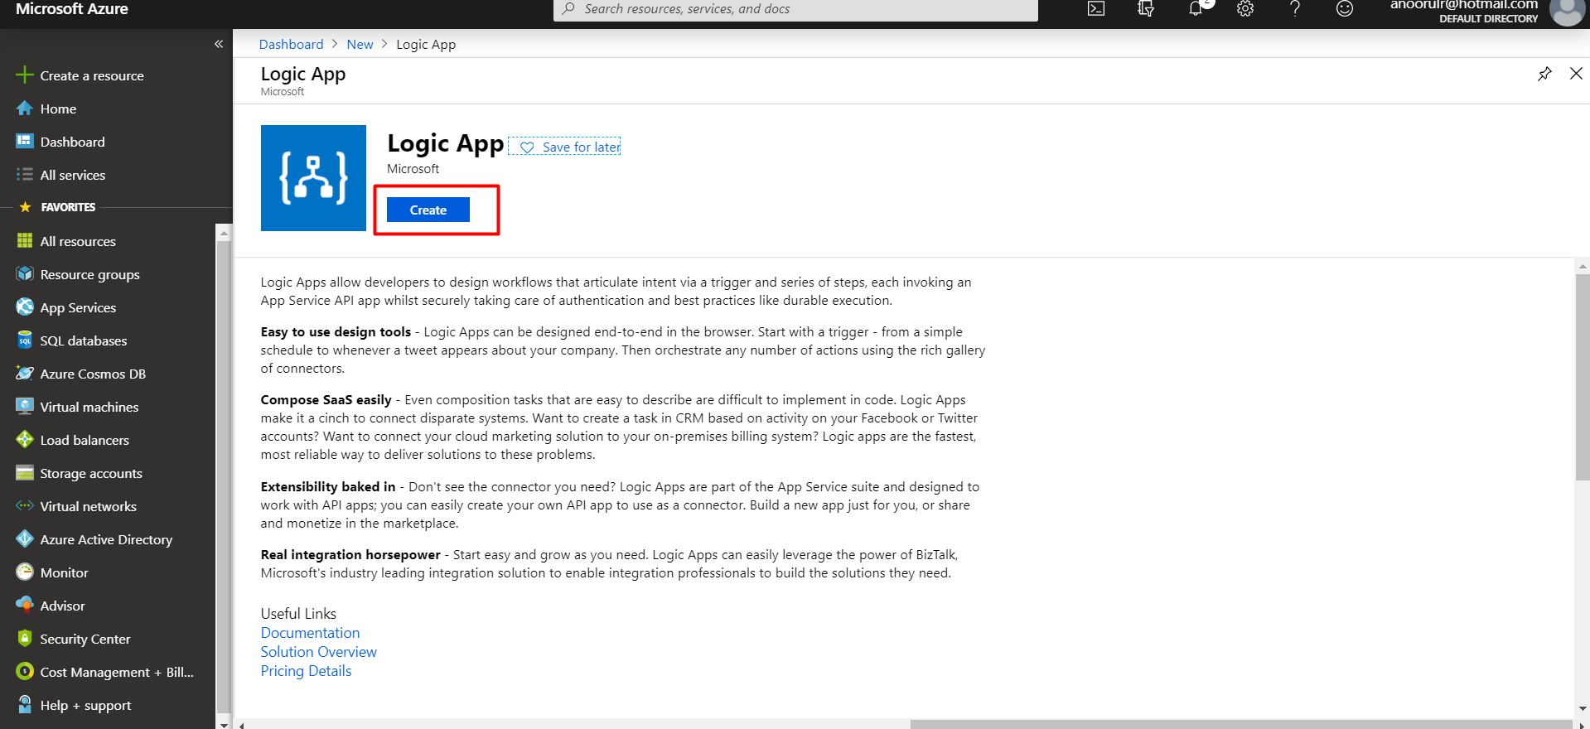

Now press create button and follow as bellow

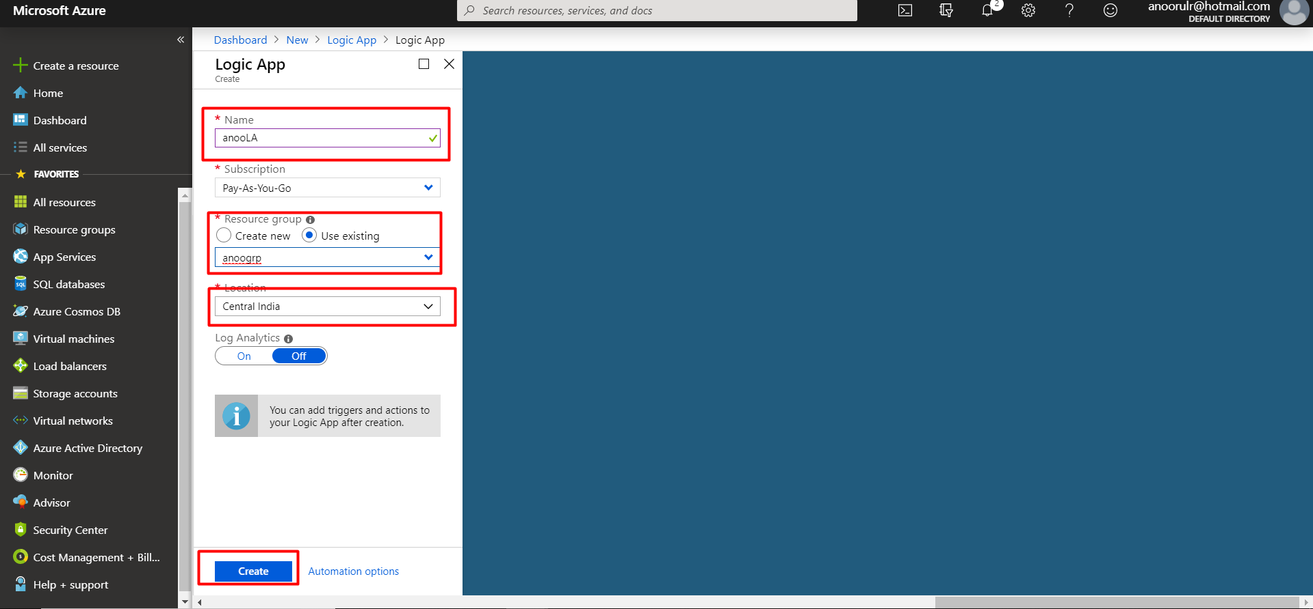

Need to enter

Name: User define identifier

Group: You can select predefined Resource group.

Geo Location: Need to select the primary geo location.

Design the logic App

Add a trigger as “When a new email arrives”

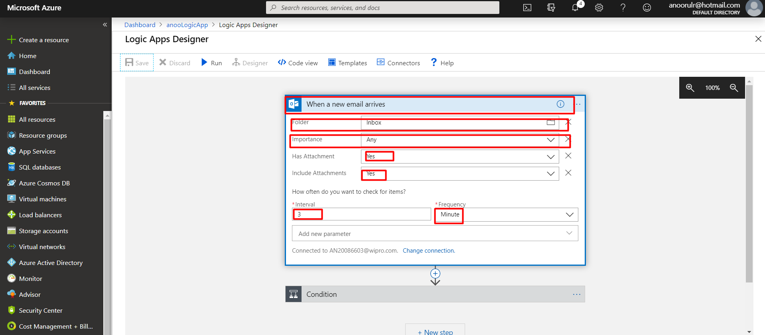

Folder: The folder may be **inbox**, or any user define folder.

Importance: It may be **any** importance.

Has Attachment: It will be **yes**

Include Attachment: **Yes**

Define Condition

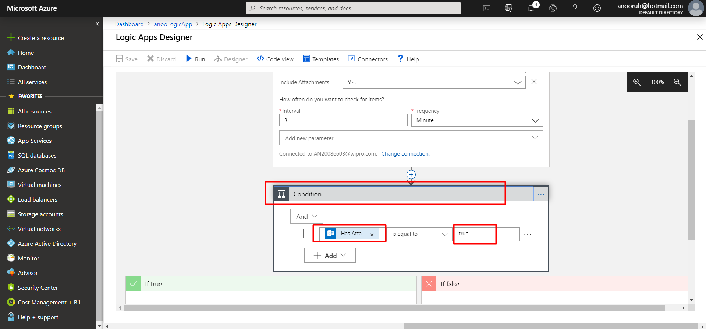

The condition will be “Has Attachment” is equal to “true”

**Define the if true condition and foreach loop**

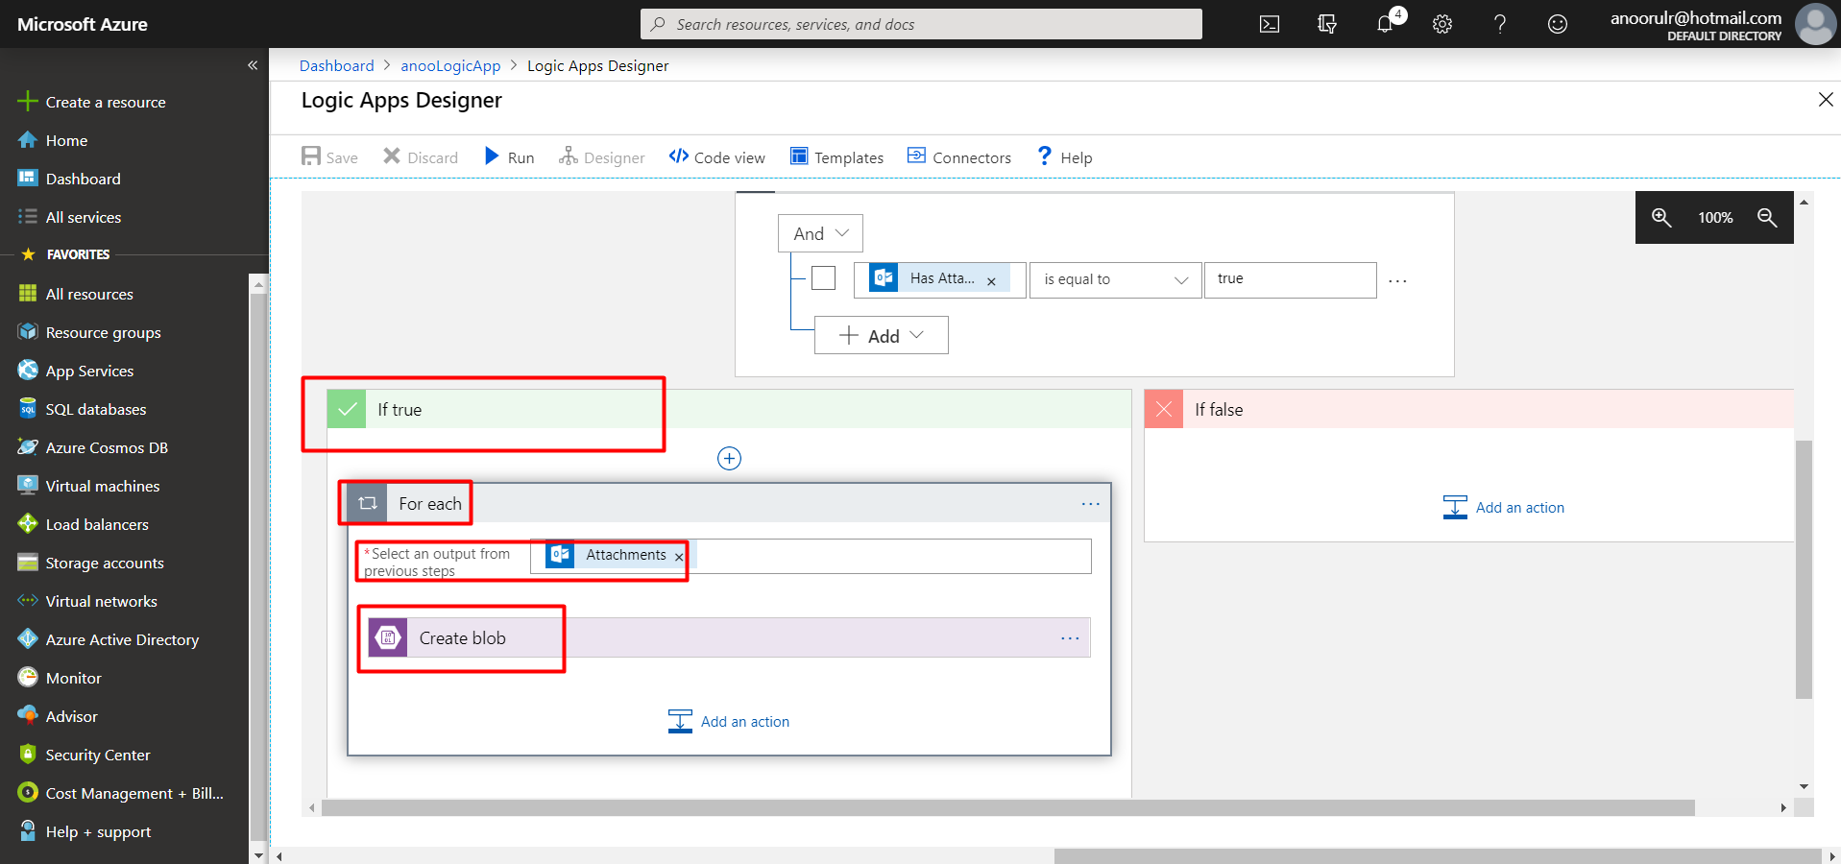

After creating this logic need to run this app and trigger a email to the particular mail-id, a file will be created into the blob-container

